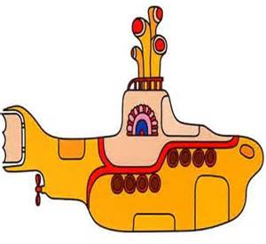 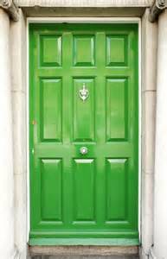

Hello to you, a Y5 House Captain ‘Hopeful’!

Thank you for showing your interest! A House Captain or Vice-Captain plays an important role in our school community, as do the House Monitors. We would like to have next year’s House Leaders in place before we finish for Summer, so that everyone is ready for September!

If you would really like to be a House Captain, we would like you to:

* Have a good read of the Job Description. Every job has one of these – it tells you what types of activities you could possibly be involved in throughout the year.
* Then have a good think – do you want to commit your time to this role? We need pupil leaders who will be dedicated to their role from the beginning to the end of the year.
* Have you got the qualities that match the job description?
* Children wishing to apply for the position of House Captain should write an application letter of no more than one side of A4. This letter should detail the ways in which you feel you meet the person specification, as well as the individual skills you possess which will enable you to carry out the roles and responsibilities. The letter must also clearly state which house you are applying to represent and the class you are in. If you have already had a leadership post in school, don’t forget to tell me about that!
* If we have many applications, we may need to interview you – don’t worry – it will be a short chat to find out more about you!
* If you are unsuccessful in your application for House Captain, you could be offered the Vice-Captain role or a House Monitor role. Remember, each House has four Leaders.

Please hand your application into Mrs Hulme or Mrs Soo at the main office on or before Fri 8th July.

Good luck!

Mrs Seddon



***Job Description***

***House Captain and Leaders***

Number of positions available: 1 Captain, 1 Vice-Captain, 2 House Monitors per House

Year Group: Year 6 (2015 - 2016)

Reports to: Mrs Seddon

Closing date: Friday 8th July at 3.15pm

**Person specification:**

The position of House Captain is very highly regarded within the school. You will aid the teachers in planning events and supporting the other children, so will need to be organised, as well as being able to follow, and give, instructions. Your attitude and behaviour should be of the highest standard. Other children in the school should view the House Captains as role models meaning your appearance, attitude, hard work and determination should be an inspirational message to all members of the school. As a positive role model, the Captains should be able to form good relationships with children of all ages.

**Key responsibilities and accountabilities:**

1. Collecting and counting house points once a week
2. Adding the ‘House Potions’ to the Potion Jars each week during assembly
3. Be ‘on playground duty’ one or two lunchtimes per week, supporting our younger pupils
4. Occasionally helping to present short ideas during assembly
5. Occasionally attending parent or governor meetings as pupil representatives
6. Representing your House during inter-house competitions
7. Working with staff to arrange inter-house events and competitions
8. Providing guided tours of the school when necessary
9. Ensuring all children are aware of behaviour expectations at PCP

10.Being the best that you can be

Good luck!